## 

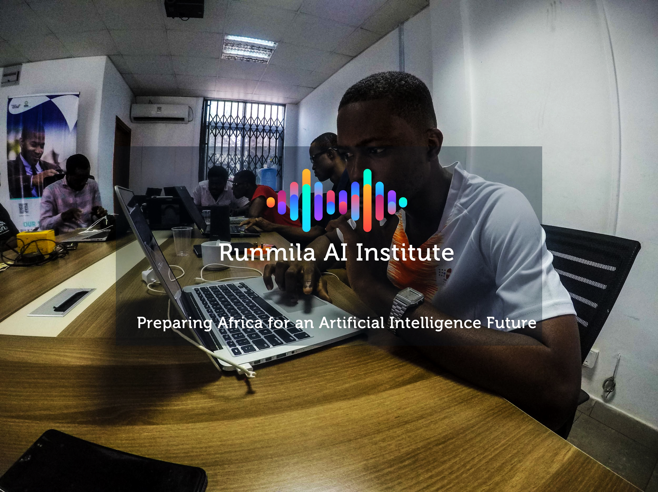

## horizontal line

AI4COVID-19 Hackathon Guidelines

03.03.2020

**─**

**Goal**

Develop a Convolutional Neural Network (or any other AI algorithm) that can diagnose COVID-19 via Chest X-Rays.

**Dataset**

Location: <https://drive.google.com/drive/folders/1QrVrwv29ivE8fBXu57QANPvcEYT_iXIA?usp=sharing>

The dataset contains Chest X-Rays with positive COVID-19 cases and negative cases, named so respectively. The 'Train' set would be used for training the model, and 'Validation' set for validating your model and helping with hyperparameter tuning.

Using the 'Test' set, create a csv with each sample name and your model's predicted label.

This hackathon ends at 3 PM GMT.

Best of Luck!